

[**Three-Dimensional Visualization and Animation**](https://fenix.tecnico.ulisboa.pt/disciplinas/AVT351795/2017-2018/1-semestre)

1st Semester 2017/2018

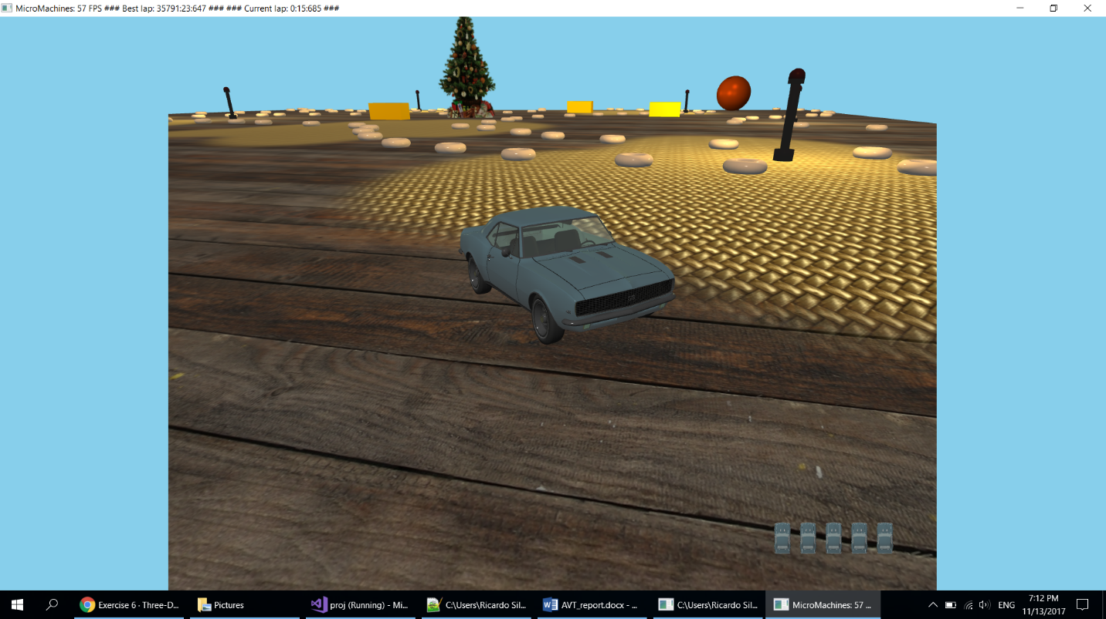

Project Report

Group 13:

78223 João Carvalho

78414 Ricardo Silva

78516 João Loureiro

# Introduction

The first part of the project was to implement the classic micro machines game where we control a car and drive around the track while avoiding obstacles and try to complete the laps as fast as possible. During this stage we implemented the movement of the objects, collisions, lighting and cameras.

The objective of the second part of the project was to implement six different techniques to improve the overall graphics of the application:

1. Stencil Test Based Effects
2. Transparent Objects
3. Fog
4. Particle Systems
5. 2D Lens Flare effect
6. Billboards

We also implemented some extras to improve the game experience.

# Stencil Test

We used stencil testing to implement the reflection of the rear-view mirror inside the car.

## Method

To accomplish this goal, we used an extra camera located inside the car and oriented towards the road behind the car. First we render the scene as usual, then we render the mirror with the stencil testing active and finally we render the scene using the backwards camera.

## Results

|  |  |
| --- | --- |
|  |  |
| Fig. 1 – View from inside the car | Fig. 2 – View from inside the car |

# Translucid Objects

The translucid objects we implemented were the car front, back and side windows.

## Method

To accomplish this we set the alpha of the material used for the windows to 0.34.  
Since we import the objects from .obj files, we can just modify the files in blender or simply edit the .mtl files directly.

|  |
| --- |
|  |
| Fig. 3 – Window part of the code in the car.mtl file |

## Results

|  |  |
| --- | --- |
|  |  |
| Fig. 4 – View from inside the car | Fig. 5 – View from outside the car |

# 2D Lens Flare

We implemented a 2D lens flare consisting of 5 textures consisting of circles, a hexagon and sunbursts.

## Method

To do this we start by converting the sun’s coordinates into screen coordinates since we will be using screen coordinates to indicate where the flare’s textures will be located.  
We then set the flare elements’ size, alpha and position according to the sun position.  
Finally, we apply the textures according to the attributes set before.

## Results

|  |  |
| --- | --- |
|  |  |
| Fig. 6 – Lens Flare Textures | Fig. 7 – Lens Flare Textures |

# Billboards

We used billboards to draw the Christmas tree in the centre of the track and to draw the sun in the sky. We decided to implement true cylindrical billboards to achieve the best quality possible.

## Method

To draw the billboards we apply a texture to a plane that rotates according to the position of the camera.

## Results

|  |  |
| --- | --- |
|  |  |
| Fig. 8 – Sun Billboard Texture | Fig. 9 – Christmas Tree Billboard Texture |

# Particles

We used a particle system to implement a snowing effect. Each particle is a cross configuration billboard with a texture applied.

## Method

To implement the snowing effect, we used a particle system where each snowflake is a particle. The particles get spawned at a random position in the sky with a random velocity towards the ground and affected by gravity. When a particle reaches the ground it disappears and a new particle gets spawned in the sky.

## Results

|  |  |
| --- | --- |
|  |  |
| Fig. 10 – Snow Particles during the day | Fig. 11 – Snow Particles during the night |

# Fog

We implemented the fog effect with the ability to turn it on and off and using an exponential function for the fog density.

## Method

The first thing we did to create the fog was to set the clear colour the same colour as the fog. We choose a different colour depending on if it’s day or night and if it’s raining or not.  
Then to calculate the fog density we used an exponential function, as said before, and to get the distance using the length.

## Results

|  |  |
| --- | --- |
|  |  |
| Fig. 12 – Fog during the night | Fig. 13 – Fog during the day with snow |

# Extras

In additional to all the requirements in the exercises, we also added two extras:

## Music

To contribute to the atmosphere of the game we added music using a library. Its one sound file played on loop for the game duration.

## Finishing Line

In our game we track and display the time the car takes to do a full lap, which translates into the score. So we also added a finishing line, using a texture, to the place where the game starts counting the time.

|  |
| --- |
|  |
| Fig. 14 – Finishing Line |

# Conclusion

We completed the project successfully by implementing all the required objects/effects using the six required techniques, plus some additional stuff that complemented the game. During the development of this project we acquired new skills and had the opportunity to learn more about modern OpenGL.